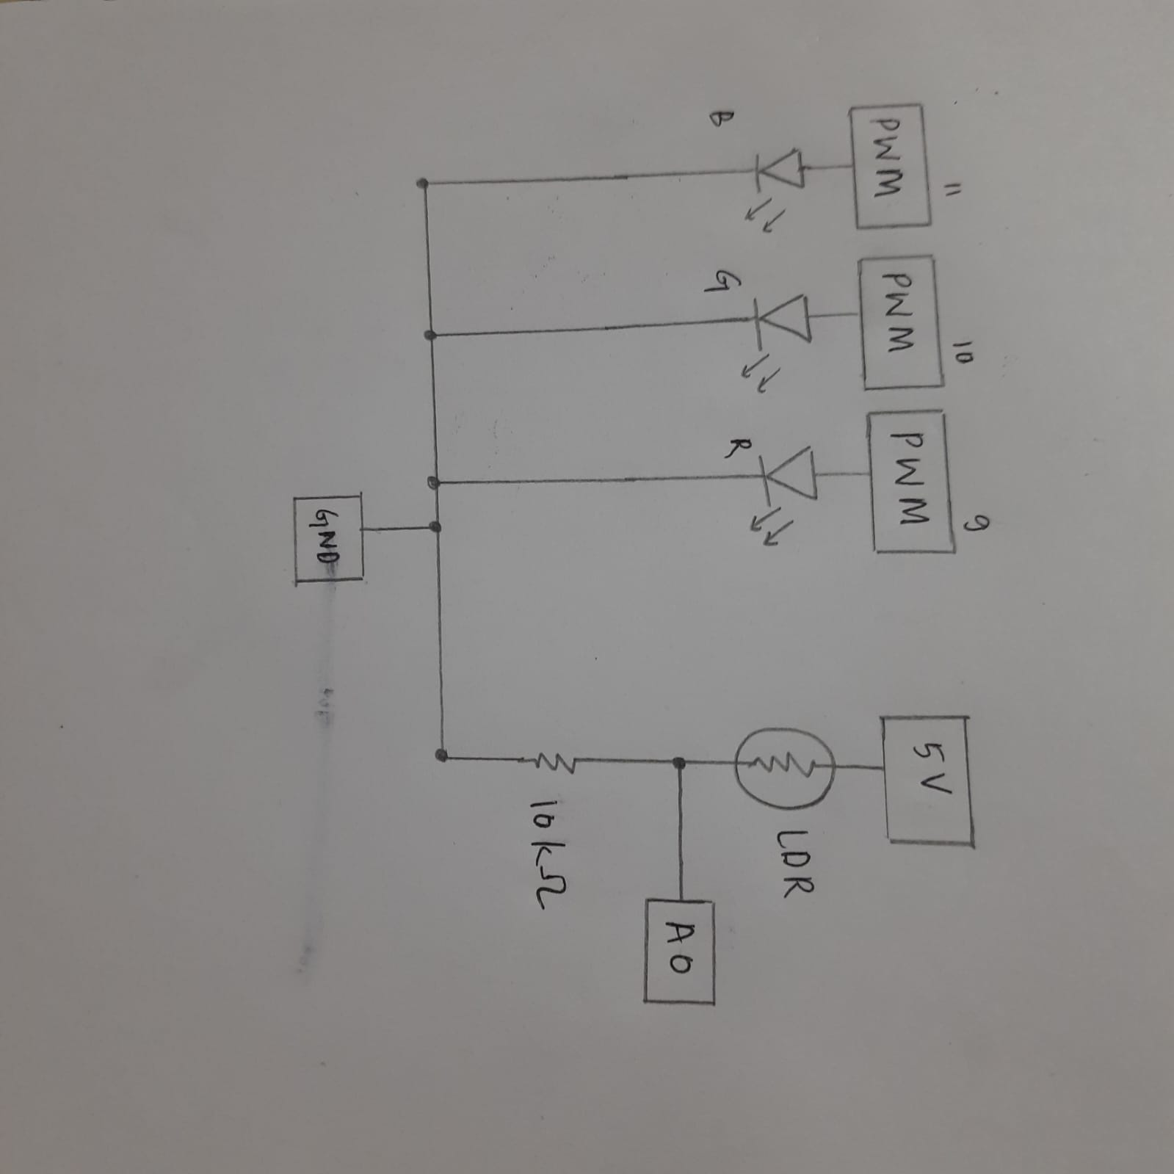

The LEDs labelled B, G and R are the blue, green and red LEDs respectively. Of course, you can connect an LED bulb of any colour to any pin, but do keep in mind that the code is written in accordance with the colour. The order of colours might change.